SEC Form 4

FORM 4

Check this box if no longer subject to Section 16. Form 4 or Form 5 obligations may continue. See Instruction 1(b).

UNITED STATES SECURITIES AND EXCHANGE COMMISSION
Washington, D.C. 20549
 |  | OMB APPROVAL
STATEMENT OF CHANGES IN BENEFICIAL OWNERSHIP
 |  | OMB Number: | 3235-0287
 |  | Estimated average burden
Filed pursuant to Section 16(a) of the Securities Exchange Act of 1934 |  | hours per response: | 0.5
or Section 30(h) of the Investment Company Act of 1940
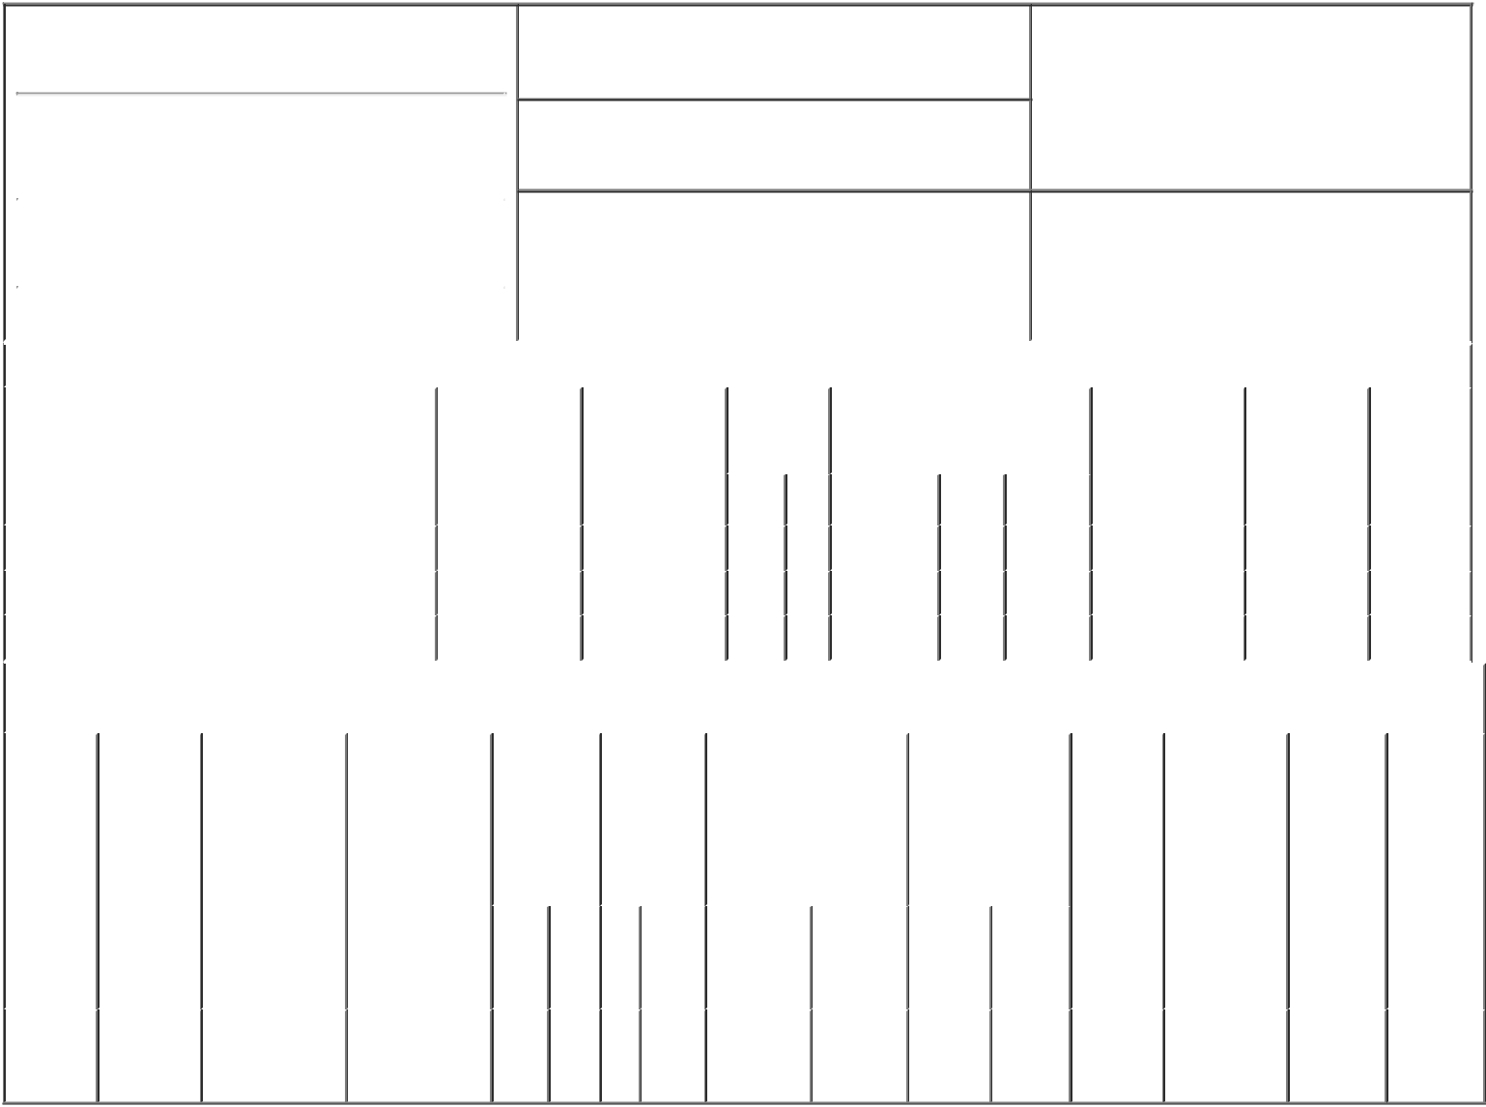

1. Name and Address of Reporting Person*
MUELLER BRIAN E

(Last) (First) (Middle)

2600 W. CAMELBACK ROAD

2. Issuer Name and Ticker or Trading Symbol

Grand Canyon Education, Inc. [ LOPE ]

3. Date of Earliest Transaction (Month/Day/Year)

11/12/2018

- Relationship of Reporting Person(s) to Issuer (Check all applicable)

X | Director | 10% Owner
X | Officer (give title | Other (specify
 | below) | below)
 | CEO

 |  |  |  |  |  |  |  | 4. If Amendment, Date of Original Filed (Month/Day/Year) |  |  |  |  |  |  | 6. Individual or Joint/Group Filing (Check Applicable
 | (Street)
 |  |  |  |  |  |  |  |  |  |  |  |  |  |  | Line)
 |  | PHOENIX |  | AZ |  | 85017 |  |  |  |  |  |  |  |  | X Form filed by One Reporting Person
 |  |  |  |  |  |  |  |  |  |  |  |  |  |  |  |  |  | Form filed by More than One Reporting
 |  | (City) |  | (State) |  | (Zip) |  |  |  |  |  |  |  |  |  |  |  | Person
 |  |  |  |  | Table I - Non-Derivative Securities Acquired, Disposed of, or Beneficially Owned
 | 1. Title of Security (Instr. 3) |  |  |  |  | 2. Transaction |  |  | 2A. Deemed | 3. |  |  | 4. Securities Acquired (A) or |  |  |  |  | 5. Amount of |  | 6. Ownership |  | 7. Nature
 |  |  |  |  |  | Date |  |  | Execution Date, |  | Transaction |  | Disposed Of (D) (Instr. 3, 4 and |  |  |  |  | Securities |  | Form: Direct |  | of Indirect
 |  |  |  |  |  | (Month/Day/Year) |  |  | if any |  | Code (Instr. |  | 5) |  |  |  |  | Beneficially |  | (D) or Indirect |  | Beneficial
 |  |  |  |  |  |  |  |  | (Month/Day/Year) 8) |  |  |  |  |  |  |  |  | Owned Following |  | (I) (Instr. 4) |  | Ownership
 |  |  |  |  |  |  |  |  |  |  |  |  |  |  |  |  |  | Reported |  |  |  | (Instr. 4)
 |  |  |  |  |  |  |  |  |  |  |  |  |  | (A) or
 |  |  |  |  |  |  |  |  |  |  | Code V |  | Amount |  | Price |  |  | Transaction(s)
 |  |  |  |  |  |  |  |  |  |  |  |  |  | (D) |  |  |  | (Instr. 3 and 4)
 | Common Stock |  |  |  |  | 11/12/2018 |  |  |  |  | M |  | 30,000 | A | $21.1 |  |  | 308,739 |  |  | D
 | Common Stock |  |  |  |  | 11/12/2018 |  |  |  |  | _{S}(1) |  | 30,000 | D | $127⁽²⁾ |  |  | 278,739 |  |  | D
 | Common Stock |  |  |  |  | 11/13/2018 |  |  |  |  | G |  | 400 | D | $0.00 |  |  | 278,339 |  |  | D
 |  |  |  |  |  | Table II - Derivative Securities Acquired, Disposed of, or Beneficially Owned
 |  |  |  |  |  | (e.g., puts, calls, warrants, options, convertible securities)
 | 1. Title of |  | 2. |  | 3. Transaction | 3A. Deemed | 4. |  | 5. Number | 6. Date Exercisable and |  |  |  | 7. Title and Amount |  |  | 8. Price of |  | 9. Number of |  | 10. | 11. Nature
 | Derivative |  | Conversion |  | Date | Execution Date, | Transaction |  | of | Expiration Date |  |  |  | of Securities |  |  | Derivative |  | derivative |  | Ownership | of Indirect
 | Security |  | or Exercise |  | (Month/Day/Year) | if any | Code (Instr. |  | Derivative | (Month/Day/Year) |  |  |  | Underlying |  |  | Security |  | Securities |  | Form: | Beneficial
 | (Instr. 3) |  | Price of |  |  | (Month/Day/Year) | 8) |  | Securities |  |  |  |  | Derivative Security |  |  | (Instr. 5) |  | Beneficially |  | Direct (D) | Ownership
 |  |  | Derivative |  |  |  |  |  | Acquired |  |  |  |  | (Instr. 3 and 4) |  |  |  |  | Owned |  | or Indirect | (Instr. 4)
 |  |  | Security |  |  |  |  |  | (A) or |  |  |  |  |  |  |  |  |  | Following |  | (I) (Instr. 4)
 |  |  |  |  |  |  |  |  | Disposed |  |  |  |  |  |  |  |  |  | Reported
 |  |  |  |  |  |  |  |  | of (D) (Instr. |  |  |  |  |  |  |  |  |  | Transaction(s)
 |  |  |  |  |  |  |  |  | 3, 4 and 5) |  |  |  |  |  |  |  |  |  | (Instr. 4)
 |  |  |  |  |  |  |  |  |  |  |  |  |  |  | Amount
 |  |  |  |  |  |  |  |  |  |  |  |  |  |  | or
 |  |  |  |  |  |  |  |  |  | Date |  | Expiration |  |  | Number
 |  |  |  |  |  |  | Code V |  | (A) (D) |  |  |  |  | Title | of
 |  |  |  |  |  |  |  |  |  | Exercisable |  | Date |  |  | Shares
 | Stock
 | Option |  | $21.1 |  | 11/12/2018 |  |  | M | 30,000 | 02/25/2015 |  | 02/24/2020 |  | Common | 30,000 |  |  | $0.00 | 70,000 |  | D
 | (Right to |  |  |  |  |  |  |  |  |  |  |  |  | Stock
Buy)

Explanation of Responses:

- These sales were effected pursuant to a 10b5-1 plan adopted by the reporting person dated September 10, 2018.

- The price reported in Column 4 is a weighted average price. These shares were sold in multiple transactions at prices ranging from $125.71 to $128.03, inclusive. The reporting person undertakes to provide to Grand Canyon Education, Inc., any security holder of Grand Canyon Education, Inc., or the staff of the Securities and Exchange Commission, upon request, full information regarding the number of shares sold at each separate price within the ranges set forth in this Form 4.

Remarks:

/s/ Lyn Bickle, Attorney-in-fact 11/14/2018

** Signature of Reporting Person Date

Reminder: Report on a separate line for each class of securities beneficially owned directly or indirectly.

* If the form is filed by more than one reporting person, see Instruction 4 (b)(v).

- Intentional misstatements or omissions of facts constitute Federal Criminal Violations See 18 U.S.C. 1001 and 15 U.S.C. 78ff(a). Note: File three copies of this Form, one of which must be manually signed. If space is insufficient, see Instruction 6 for procedure.
Persons who respond to the collection of information contained in this form are not required to respond unless the form displays a currently valid OMB Number.

LIMITED POWER OF ATTORNEY

FOR SECTION 16(a) REPORTING

KNOW ALL PERSONS BY THESE PRESENTS, that the undersigned hereby makes, constitutes and appoints Daniel E. Bachus, Dan Steimel and Lyn Bickle, and each of them, as the undersigned's true and lawful attorney-in-fact (the "Attorney-in Fact"), with full power of substitution and resubstitution, each with the power to act alone for the undersigned and in the undersigned's name, place and stead, in any and all capacities to:

- prepare, execute and file with the Securities and Exchange Commission, any national securities exchange or securities quotation system and Grand Canyon

Education, Inc. (the "Company") any and all reports (including any amendment thereto) of the undersigned required or considered advisable under Section 16(a) of the Securities Exchange Act of 1934, as amended (the "Exchange Act"), and the rules and regulations thereunder, with respect to the equity securities of the Company, including Forms 3, 4 and 5; and

- obtain, as the undersigned's representative and on the undersigned's behalf, information regarding transactions in the Company's equity securities from any

third party, including the Company and any brokers, dealers, employee benefit plan administrators and trustees, and the undersigned hereby authorizes any such third party to release any such information to the Attorney-in-Fact.

The undersigned acknowledges that:

- this Limited Power of Attorney authorizes, but does not require, the Attorney-in-Fact to act at his or her discretion on information provided to such Attorney-in-Fact without independent verification of such information;

- any documents prepared or executed by the Attorney-in-Fact on behalf of the undersigned pursuant to this Limited Power of Attorney will be in such form and

will contain such information as the Attorney-in-Fact, in his or her discretion, deems necessary or desirable;

- neither the Company nor the Attorney-in-Fact assumes any liability for the undersigned's responsibility to comply with the requirements of Section 16 of

the Exchange Act, any liability of the undersigned for any failure to comply with such requirements, or any liability of the undersigned for disgorgement of profits under Section 16(b) of the Exchange Act; and

- this Limited Power of Attorney does not relieve the undersigned from responsibility for compliance with the undersigned's obligations under Section

16 of the Exchange Act, including, without, limitation, the reporting requirements under Section 16(a) of the Exchange Act.

The undersigned hereby grants to the Attorney-in-Fact full power and authority to do and perform each and every act and thing requisite, necessary or

convenient to be done in connection with the foregoing, as fully, to all intents and purposes, as the undersigned might or could do in person, hereby ratifying and confirming all that the Attorney-in-Fact, or his or her substitute or substitutes, shall lawfully do or cause to be done by authority of this Limited Power of Attorney.

This Limited Power of Attorney shall remain in full force and effect until the undersigned is no longer required to file Forms 4 or 5 with respect to the undersigned's transactions in equity securities of the Company, unless earlier revoked by the undersigned in a signed writing delivered to the Attorney-in-Fact.

This Limited Power of Attorney shall be governed and construed in accordance the laws of the State of Arizona without regard to conflict-of-law principles.
IN WITNESS WHEREOF, the undersigned has executed this Limited Power of Attorney as of November 12, 2018.
Signature: /s/ Brian Mueller

Print Name: Brian Mueller

