​
UNITED STATES
SECURITIES AND EXCHANGE COMMISSION
Washington, D.C. 20549
​
​
SCHEDULE 14A
Proxy Statement Pursuant to Section 14(a) of the
Securities Exchange Act of 1934
(Amendment No. )
​
​
Filed by the Registrant ☒ Filed by a Party other than the Registrant ☐
Check the appropriate box:
​
​ | ​
☐ | Preliminary Proxy Statement
​ | ​
☐ | Confidential, For Use of the Commission Only (as permitted by Rule 14a-6(e)(2))
​ | ​
☐ | Definitive Proxy Statement
​ | ​
☒ | Definitive Additional Materials
​ | ​
☐ | Soliciting Material Pursuant to § 240.14a-12
​
Grand Canyon Education, Inc.
(Name of Registrant as Specified in Its Charter)
​
(Name of Person(s) Filing Proxy Statement, if Other Than the Registrant)
Payment of Filing Fee (Check the appropriate box):
​
​ | ​ | ​
☒ | No fee required.
​ | ​ | ​
​ | ​ | ​
☐ | Fee paid previously with preliminary material.
​ | ​ | ​
☐ | Fee computed on table in exhibit required by Item 25(b) per Exchange Act Rules 14a6(i)(1) and 0-11.
​ | ​ | ​
​

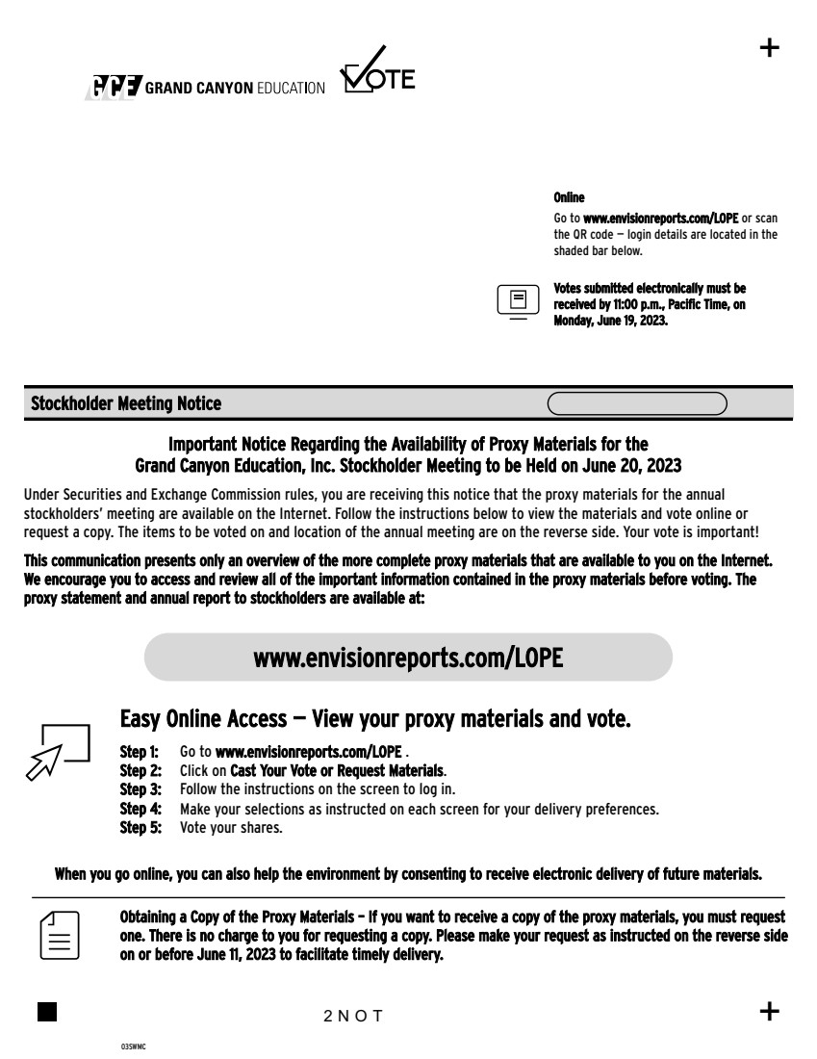 | Step 1: Go to www.envisionreports.com/LOPE . Step 2: Click on Cast Your Vote or Request Materials. Step 3: Follow the instructions on the screen to log in. www.envisionreports.com/LOPE Online Go to www.envisionreports.com/LOPE or scan the QR code — login details are located in the shaded bar below. Stockholder Meeting Notice 03SWMC + + Important Notice Regarding the Availability of Proxy Materials for the Grand Canyon Education, Inc. Stockholder Meeting to be Held on June 20, 2023 Under Securities and Exchange Commission rules, you are receiving this notice that the proxy materials for the annual stockholders’ meeting are available on the Internet. Follow the instructions below to view the materials and vote online or request a copy. The items to be voted on and location of the annual meeting are on the reverse side. Your vote is important! This communication presents only an overview of the more complete proxy materials that are available to you on the Internet. We encourage you to access and review all of the important information contained in the proxy materials before voting. The proxy statement and annual report to stockholders are available at: Obtaining a Copy of the Proxy Materials – If you want to receive a copy of the proxy materials, you must request one. There is no charge to you for requesting a copy. Please make your request as instructed on the reverse side on or before June 11, 2023 to facilitate timely delivery. 2NOT Easy Online Access — View your proxy materials and vote. When you go online, you can also help the environment by consenting to receive electronic delivery of future materials. Votes submitted electronically must be received by 11:00 p.m., Pacific Time, on Monday, June 19, 2023. Step 4: Make your selections as instructed on each screen for your delivery preferences. Step 5: Vote your shares.
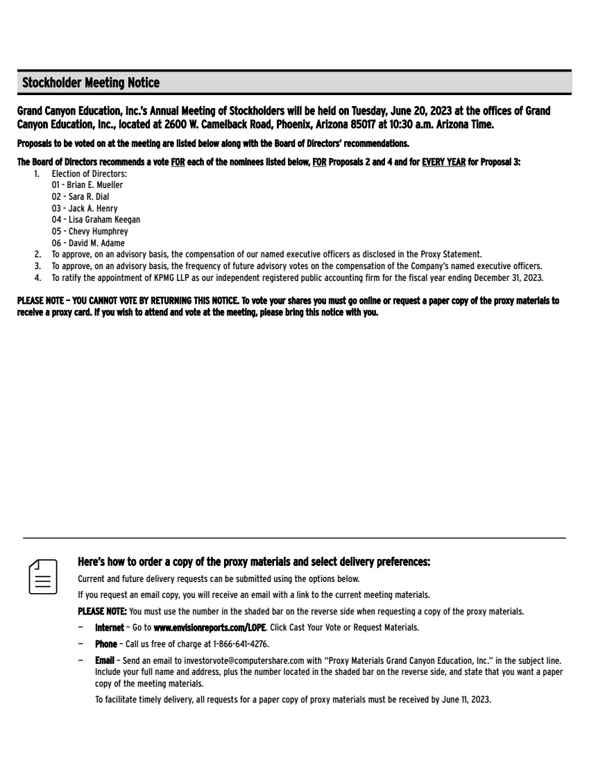 | Here’s how to order a copy of the proxy materials and select delivery preferences: Current and future delivery requests can be submitted using the options below. If you request an email copy, you will receive an email with a link to the current meeting materials. PLEASE NOTE: You must use the number in the shaded bar on the reverse side when requesting a copy of the proxy materials. — Internet – Go to www.envisionreports.com/LOPE. Click Cast Your Vote or Request Materials. — Phone – Call us free of charge at 1-866-641-4276. — Email – Send an email to investorvote@computershare.com with “Proxy Materials Grand Canyon Education, Inc.” in the subject line. Include your full name and address, plus the number located in the shaded bar on the reverse side, and state that you want a paper copy of the meeting materials. To facilitate timely delivery, all requests for a paper copy of proxy materials must be received by June 11, 2023. Grand Canyon Education, Inc.’s Annual Meeting of Stockholders will be held on Tuesday, June 20, 2023 at the offices of Grand Canyon Education, Inc., located at 2600 W. Camelback Road, Phoenix, Arizona 85017 at 10:30 a.m. Arizona Time. Proposals to be voted on at the meeting are listed below along with the Board of Directors’ recommendations. The Board of Directors recommends a vote FOR each of the nominees listed below, FOR Proposals 2 and 4 and for EVERY YEAR for Proposal 3: 1. Election of Directors: 01 - Brian E. Mueller 02 - Sara R. Dial 03 - Jack A. Henry 04 - Lisa Graham Keegan 05 - Chevy Humphrey 06 - David M. Adame 2. To approve, on an advisory basis, the compensation of our named executive officers as disclosed in the Proxy Statement. 3. To approve, on an advisory basis, the frequency of future advisory votes on the compensation of the Company’s named executive officers. 4. To ratify the appointment of KPMG LLP as our independent registered public accounting firm for the fiscal year ending December 31, 2023. PLEASE NOTE – YOU CANNOT VOTE BY RETURNING THIS NOTICE. To vote your shares you must go online or request a paper copy of the proxy materials to receive a proxy card. If you wish to attend and vote at the meeting, please bring this notice with you. Stockholder Meeting Notice

