SEC Form 3
FORM 3 | UNITED STATES SECURITIES AND EXCHANGE
 | COMMISSION
 |  |  | OMB APPROVAL
 | Washington, D.C. 20549
 |  |  | OMB Number: | 3235-
 | INITIAL STATEMENT OF BENEFICIAL OWNERSHIP OF |  |  | 0104
 |  |  | Estimated average burden
 | SECURITIES |  |  | 0.5
hours per
response:

Filed pursuant to Section 16(a) of the Securities Exchange Act of 1934
or Section 30(h) of the Investment Company Act of 1940
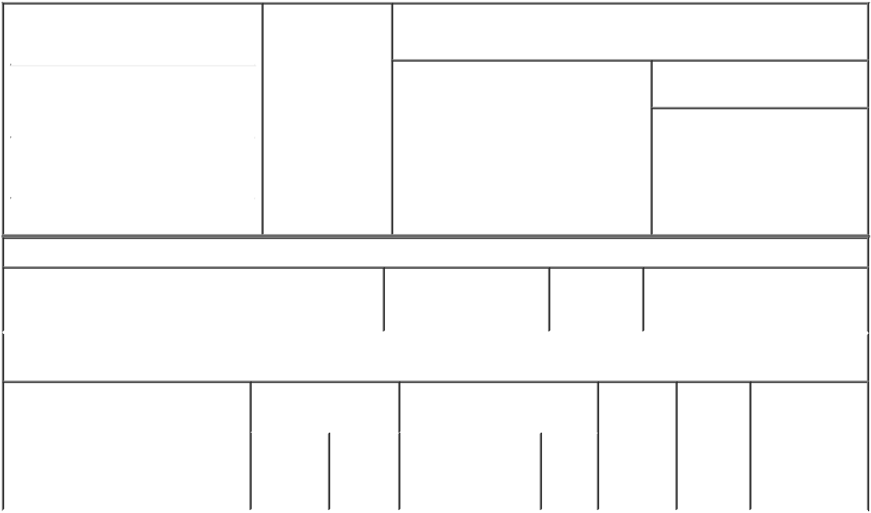

1. Name and Address of Reporting Person |  |  | * | 2. Date of Event
 |  |  |  | Requiring Statement
 | Adame David
 |  |  |  | (Month/Day/Year)
 |  |  |  | 06/22/2021

3. Issuer Name and Ticker or Trading Symbol

Grand Canyon Education, Inc. [ LOPE ]

(Last) | (First) | (Middle)
2600 W. CAMELBACK ROAD
(Street)
PHOENIX | AZ | 85017
(City) | (State) | (Zip)

- Relationship of Reporting Person(s) to Issuer
(Check all applicable)
X Director 10% Owner

Officer (give Other (specify
title below) below)

- If Amendment, Date of Original Filed (Month/Day/Year)

- Individual or Joint/Group Filing (Check Applicable Line)

- Form filed by One Reporting Person

Form filed by More than One Reporting Person

Table I - Non-Derivative Securities Beneficially Owned

 | 1. Title of Security (Instr. 4) | 2. Amount of Securities | 3. Ownership | 4. Nature of Indirect Beneficial
 |  | Beneficially Owned (Instr. | Form: Direct | Ownership (Instr. 5)
 |  | 4) | (D) or Indirect
 |  |  | (I) (Instr. 5)

Table II - Derivative Securities Beneficially Owned

(e.g., puts, calls, warrants, options, convertible securities)

1. Title of Derivative Security (Instr. 4) | 2. Date Exercisable and |  | 3. Title and Amount of Securities |  |  | 4. |  |  | 5. |  | 6. Nature of
 | Expiration Date |  | Underlying Derivative Security |  |  | Conversion |  |  | Ownership |  | Indirect Beneficial
 | (Month/Day/Year) |  | (Instr. 4) |  |  | or Exercise |  |  | Form: |  | Ownership (Instr.
 |  |  |  |  |  | Price of |  |  | Direct (D) |  | 5)
 |  |  |  | Amount
 |  |  |  |  |  | Derivative |  |  | or Indirect
 |  |  |  | or |  | Security |  |  | (I) (Instr. 5)
 |  |  |  | Number
 | Date | Expiration |  | of
 | Exercisable | Date | Title | Shares
Explanation of Responses:
Remarks:
No securities are beneficially owned.
 |  |  |  | /s/ David M. Adame, by
 |  |  |  | Lyn Bickle, as Attorney- |  |  |  |  | 06/24/2021
 |  |  |  | in-fact

** Signature of Reporting | Date
Person
Reminder: Report on a separate line for each class of securities beneficially owned directly or indirectly.
* If the form is filed by more than one reporting person, see Instruction 5 (b)(v).

- Intentional misstatements or omissions of facts constitute Federal Criminal Violations See 18 U.S.C. 1001 and 15 U.S.C. 78ff(a). Note: File three copies of this Form, one of which must be manually signed. If space is insufficient, see Instruction 6 for procedure.
Persons who respond to the collection of information contained in this form are not required to respond unless the form displays a currently valid OMB Number.

LIMITED POWER OF ATTORNEY
FOR SECTION 16(a) REPORTING

KNOW ALL PERSONS BY THESE PRESENTS, that the undersigned hereby makes, constitutes and appoints Daniel E. Bachus, Daniel J. Steimel and Lyn Bickle, and each of them, as the undersigned's true and lawful attorney-in-fact (the "Attorney-in Fact"), with full power of substitution and resubstitution, each with the power to act alone for the undersigned and in the undersigned's name, place and stead, in any and all capacities to:

- prepare, execute and file with the Securities and Exchange Commission, any national securities exchange or securities quotation system and Grand Canyon

Education, Inc. (the "Company") any and all reports (including any amendment thereto) of the undersigned required or considered advisable under Section 16(a) of the Securities Exchange Act of 1934, as amended (the "Exchange Act"), and the rules and regulations thereunder, with respect to the equity securities of the Company, including Forms 3, 4 and 5; and

- obtain, as the undersigned's representative and on the undersigned's behalf, information regarding transactions in the Company's equity securities from any

third party, including the Company and any brokers, dealers, employee benefit plan administrators and trustees, and the undersigned hereby authorizes any such third party to release any such information to the Attorney-in-Fact.

The undersigned acknowledges that:

- this Limited Power of Attorney authorizes, but does not require, the Attorney-in-Fact to act at his or her discretion on information provided to such Attorney-in-Fact without independent verification of such information;

- any documents prepared or executed by the Attorney-in-Fact on behalf of the undersigned pursuant to this Limited Power of Attorney will be in such form and

will contain such information as the Attorney-in-Fact, in his or her discretion, deems necessary or desirable;

- neither the Company nor the Attorney-in-Fact assumes any liability for the undersigned's responsibility to comply with the requirements of Section 16 of

the Exchange Act, any liability of the undersigned for any failure to comply with such requirements, or any liability of the undersigned for disgorgement of profits under Section 16(b) of the Exchange Act; and

- this Limited Power of Attorney does not relieve the undersigned from responsibility for compliance with the undersigned's obligations under Section

16 of the Exchange Act, including, without, limitation, the reporting requirements under Section 16(a) of the Exchange Act.

The undersigned hereby grants to the Attorney-in-Fact full power and authority to do and perform each and every act and thing requisite, necessary or

convenient to be done in connection with the foregoing, as fully, to all intents and purposes, as the undersigned might or could do in person, hereby ratifying and confirming all that the Attorney-in-Fact, or his or her substitute or substitutes, shall lawfully do or cause to be done by authority of this Limited Power of Attorney.

This Limited Power of Attorney shall remain in full force and effect until the undersigned is no longer required to file Forms 4 or 5 with respect to the undersigned's transactions in equity securities of the Company, unless earlier revoked by the undersigned in a signed writing delivered to the Attorney-in-Fact.

This Limited Power of Attorney shall be governed and construed in accordance the laws of the State of Arizona without regard to conflict-of-law principles.

IN WITNESS WHEREOF, the undersigned has executed this Limited Power of Attorney as of June 16, 2021.

Signature: /s/ David Adame
Print Name: David Adame

