UNITED STATES

SECURITIES AND EXCHANGE COMMISSION
Washington, D.C. 20549

SCHEDULE 14A

Proxy Statement Pursuant to Section 14(a) of the

Securities Exchange Act of 1934
(Amendment No. )

Filed by the Registrant ☒ Filed by a Party other than the Registrant ☐

Check the appropriate box:

- Preliminary Proxy Statement

- Confidential, For Use of the Commission Only (as permitted by Rule 14a-6(e)(2))

- Definitive Proxy Statement

- Definitive Additional Materials

- Soliciting Material Pursuant to § 240.14a-12

Grand Canyon Education, Inc.

(Name of Registrant as Specified in Its Charter)

(Name of Person(s) Filing Proxy Statement, if Other Than the Registrant)

Payment of Filing Fee (Check the appropriate box):

- No fee required.

- Fee computed on table below per Exchange Act Rules 14a-6(i)(1) and 0-11.

  - Title of each class of securities to which transaction applies:

  - Aggregate number of securities to which transaction applies:

  - Per unit price or other underlying value of transaction computed pursuant to Exchange Act Rule 0-11 (set forth the amount on which the filing fee is calculated and state how it was determined):

  - Proposed maximum aggregate value of transaction:

  - Total fee paid:

- Fee paid previously with preliminary material.

- Check box if any part of the fee is offset as provided by Exchange Act Rule 0-11(a)(2) and identify the filing for which the offsetting fee was paid previously. Identify the previous filing by registration statement number, or the Form or Schedule and the date of its filing.

  - Amount previously paid:

  - Form, Schedule or Registration Statement No.:

- Filing Party:

- Date Filed:

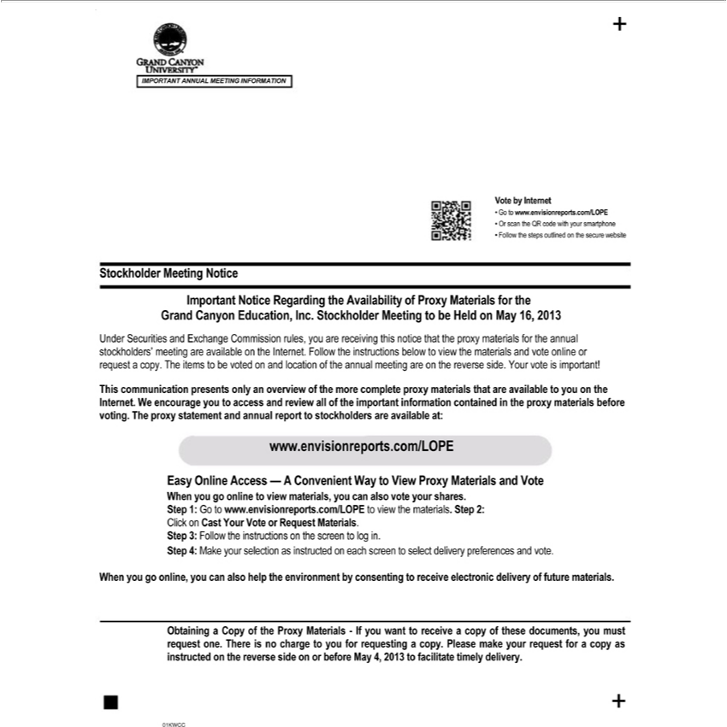

IMPORTANT ANNUAL MEETING INFORMATION Vote by Internet Go to www.envisionreports.com/LOPE Or scan the QR code with your smartphone Follow the steps outlined on the secure website
Stockholder Meeting Notice Important Notice Regarding the Availability of Proxy Materials for the Grand Canyon Education, Inc. Stockholder Meeting to be Held | May 16, 2013 Under Securities and
Exchange Commission rules, you are receiving this notice that the proxy materials for the annual stockholders’ meeting are available on the Internet. Follow the instructions below to view the materials and vote
online or request a copy. The items to be voted on and location of the annual meeting are on the reverse side. Your vote is important! This communication presents only an overview of the more complete proxy
materials that are available to you on the Internet. W encourage you to access and review all of the important information contained in the proxy materials before voting. The proxy statement and annual report
to stockholders are available at: www.envisionreports.com/LOPE Easy Online Access — A Convenient Way to View Proxy Materials and Vote When you go online to view materials, you can also vote your
hares. Step 1: Go to www.envisionreports.com/LOPE to view the materials. Step 2: Click on Cast Your Vote or Request Materials. Step 3: Follow the instructions | the screen to log in. Step 4: Make your
selection as instructed on each screen to select delivery preferences and vote. When you go online, you can also help the environment by consenting to receive electronic delivery of future materials. Obtaining a Copy of the Proxy Materials - If you want to receive a copy of these documents, you must request one. There is no charge to you for requesting a copy. Please make your request for a copy as instructed on the reverse side on or before May 4, 2013 to facilitate timely delivery.

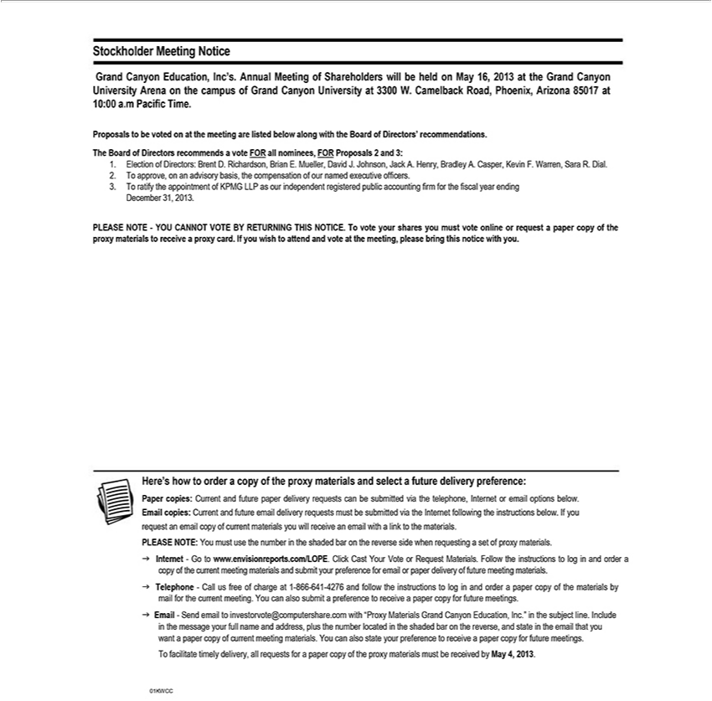

Stockholder Meeting Notice Grand Canyon |  |  | Inc’s. Annual Meeting of Shareholders will be held on May 16, 2013 at the Grand Canyon University Arena on the campus of Grand Canyon University at
3300 W. Camelback |  | Phoenix, ArizonaEducation,8501710:00 .m Pacific Time. Proposals |  | be voted on at the meeting are listed below along with the Board of Directors’ recommendations. The Board of
Di ectors |  | Road,vote FOR all nominees, FOR Proposals 2 and 3: 1. Election of Directors: Brent D. Richardson, Brian E. Mueller, David J. Johnson, Jack A. Henry, Bradley A. Casper, Kevin F. Warren,
Sara R. Dial.recommends2.Tapprove, on an advisory basis, the compensation of our named executive officers. 3. o ratify the |  |  |  |  |  | of KPMG LLP as our independent registered public accounting firm for the
fiscal | ending December 31, 2013. PLEASE NOTE - YOU CANNOT VOTE BY RETURNING THIS NOTICE. T vote your shares you must vote online or request a paper copy of the proxy materials to
receiveyearproxy card. If you wish to attend and vote at the meeting, please bring this notice with you. Here’s how to orderappointmentcopyof the proxy materials and select a future delivery preference: Paper copies:
Current and future paper delivery requests can be submitted via the telephone, Internet or email options below. |  |  |  |  |  | copies: Current and future email delivery requests must |  | submitted via the Internet
following the instructions below. If you request an email copy of current materials you will receive an email withEmaillink to the materials. PLEASE NOTE: You must use the number in the shaded bar on the
reverse side when requesting a set of proxy materials. g Internet - Go to www.envisionreports.com/LOPE. Click Cast Your Vote or Request |  |  |  |  |  |  | . Follow the instructions to log in and order a copy of the
current meeting materials and submit your preference for email or paper delivery of future meeting materials. g Tele |  |  |  |  |  | hone - Call us free of chargeMaterials1-866-641-4276 and follow the instructions log in and
order a paper copy of the materials by mail for the current meeting. You can also submit |  |  |  | preference to receive | paper copy for future meetings. g Email - Send email to |  |  | .com with
“Proxy Materials Grand Canyon Education, Inc.” in the subject line. Include in the message your full name and address, plus the number located in the shaded bar on the reverse,investorvote@computershareandstatetheemail that you ^{must}want a paper copy of current meeting materials. You can also state your preference to receive a paper copy for future meetings. To facilitate timely delivery, all requests for a paper copy of the proxy materials
be received by May 4, 2013.

