UNITED STATES

SECURITIES AND EXCHANGE COMMISSION
Washington, D.C. 20549

SCHEDULE 14A

Proxy Statement Pursuant to Section 14(a) of the

Securities Exchange Act of 1934
(Amendment No. )

Filed by the Registrant ☒ Filed by a Party other than the Registrant ☐

Check the appropriate box:

- Preliminary Proxy Statement

- Confidential, For Use of the Commission Only (as permitted by Rule 14a-6(e)(2))

- Definitive Proxy Statement

- Definitive Additional Materials

- Soliciting Material Pursuant to § 240.14a-12

Grand Canyon Education, Inc.

(Name of Registrant as Specified in Its Charter)

(Name of Person(s) Filing Proxy Statement, if Other Than the Registrant)

Payment of Filing Fee (Check the appropriate box):

- No fee required.

- Fee computed on table below per Exchange Act Rules 14a-6(i)(1) and 0-11.

  - Title of each class of securities to which transaction applies:

  - Aggregate number of securities to which transaction applies:

  - Per unit price or other underlying value of transaction computed pursuant to Exchange Act Rule 0-11 (set forth the amount on which the filing fee is calculated and state how it was determined):

  - Proposed maximum aggregate value of transaction:

  - Total fee paid:

- Fee paid previously with preliminary material.

- Check box if any part of the fee is offset as provided by Exchange Act Rule 0-11(a)(2) and identify the filing for which the offsetting fee was paid previously. Identify the previous filing by registration statement number, or the Form or Schedule and the date of its filing.

  - Amount previously paid:

  - Form, Schedule or Registration Statement No.:

  - Filing Party:

  - Date Filed:

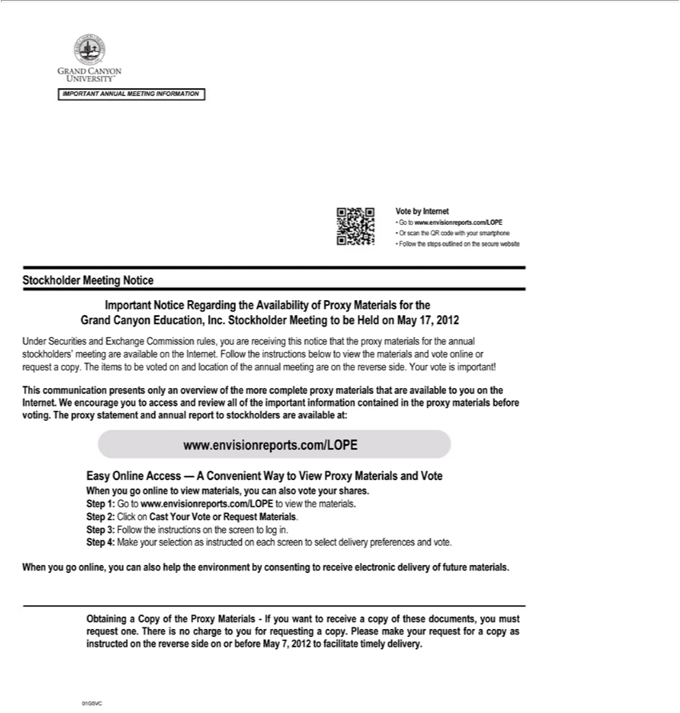

IMPORTANT ANNUAL MEETING INFORMATION
Vote by Internet
Go to www.envisionreports.com/LOPE
Or scan the QR code with your smartphone
Follow the steps outlined on the secure website
Stockholder Me ting Notice
Important Notice Regarding the Availability of Proxy Materials for the
Grand Canyon Education, Inc. Stockholder Meeting to be Held on May 17, 2012
Under Securities and Exchange |  | rules, you are receiving this notice that the proxy materials for the an ual
stockholders’ meeting are available |  | the Internet. Follow the instructions below to view the materials and vote online
request | copy. The items to be votedCommissionand location of the annual meeting are on the reverse side. Your vote is important!
This communication presents only an overview of the more complete proxy materials that are available to you on the Internet. We encourage you to access and review all of the important information contained
in the proxy materials before voting. The proxy statement and annual report to stockholders are available at:
www.envisionreports.com/LOPE
Easy Online Access — A Convenient Way to View Proxy Materials and Vote
When you go online to view materials, you can also vote your shares. Step 1: Go to www.envisionreports.com/LOPE to view the materials.
2: Click on Cast Your Vote or Request Materials.
3: | Follow the instructions on the screen to log in.
Step 4: | Make your selection as instructed on each screen to select delivery preferences and vote.
When you go online, you can also help the environment by consenting to receive electronic delivery of future materials.
Obtaining a Copy of the Proxy Materials - If you want to receive_{facilitate}copy of these documents, you must request one. There is no charge to you for requesting a copy. Please make your request for a copy as
instructed on the reverse side on or before May 7, 2012 to timely delivery.

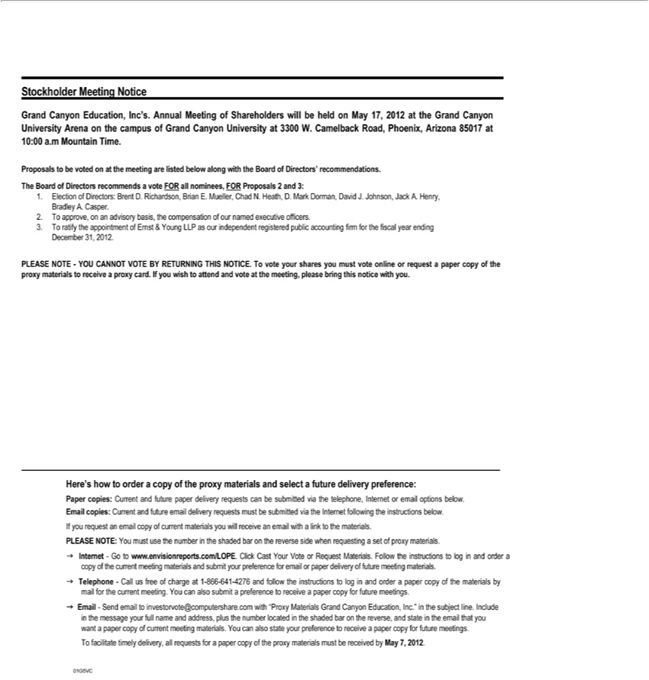

Stockholder Meeting Notice |  | Meeting of Shareholders will be held on May 17, 2012 at the Grand Canyon University Arena on the campus of Grand Canyon University at 3300 W. Camelback Road,
Grand Canyon Education, Inc’s.
hoenix, Arizona 85017 at 10:00Annual.Mountain Time.
Proposals to be voted on at the meeting are listed below along with the Board of Directors’ recommendations.
The Board of Directors recommends |  | vote FOR all nominees, FOR Proposals 2 and 3:
1. Election of Directors: Brent D. Richardson, Brian E. Mueller, Chad N. Heath, D. Mark Dorman, David J. Johnson, Jack A. Henry,
Bradley A. Casper.
2 | approve, on an advisory basis, the compensation of our named executive officers.
3. To ratify the appointment of Ernst & Young LLP as our independent registered public accounting firm for the fiscal year ending
December 31, 2012.
PLEASE NOTE - YOU CANNOT VOTE BY RETURNING THIS NOTICE. To vote your shares you must vote online or request a paper copy of the proxy materials to receive a proxy card. If you wish to
attend and vote at the meeting, please bring this notice with you.
Her ’s how to order a copy of the proxy materials and select a future delivery preference:
Paper copies: Current and future paper delivery requests can be submitted via the telephone, Internet or email options below. Email copies: Current and future email delivery requests must be submitted via the
nternet followi g the instructions below. |  |  | .
If you request an email copy of current materials you will receive an email with a link to the |  |  | .
PLEASE NOTE: You must use the number in the shaded bar on the reverse side when requestingmaterialsset of proxy materials.
g Internet - Go to www.envisionreports.com/LOPE. Click Cast Your Vote or Request Materials. Follow the instructions to log in and order a
copy of the current meeting materials and submit your preference for email or paper delivery of future meeting materials.
g Telephone - Call us free of charge at 1-866-641-4276 and follow the instructions to log in and order a paper copy of the materials by
mail for the current meeting. You can also submit preference to receive paper copy for future meetings.
g Email - Send email to investorvote@computershare.com with “Proxy Materials Grand Canyon Education, Inc.” in the subject line. Include
in the message your full name and address, plus the number located in the shaded bar on the reverse, and state in the email that you
want | paper copy of current meeting | . You can also state your preference to receive a paper copy for future meetings.
facilitate materials
01G5VCTo timely delivery, all requests for paper copy of the proxy materials must be received by May 7, 2012.

